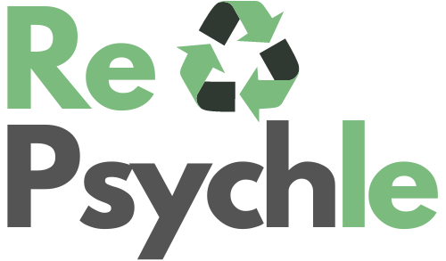

Register your Application:



Purpose of the application:

The purpose of this application is to serve users who want to become more efficient when it comes to recycling without having to guess how to recycle an object. Many applications and services that are delivering products through smart devices are not creating anything specifically new. They are delivering services in a medium that is accessible to a user through a greater technological lens.

An example of this is Uber. When originally launched, the purpose was to transport people from one destination to another in a quicker time than a Taxi would. Taxi drivers would typically need to memorize the neighborhood to provide a service. Uber drivers are given an iPhone to use so they can track their metrics while knowing how to pickup and drop off someone. The result is that while Uber would cost a user more money to use, the convenience factor and time makes up for this.

Bringing recycling to more users by making it easier without guessing when to take out their garbage, which regions require specific items to be recycled, or how other users make use of their reusable products.

Identify:

To complete this application, I would need to do some more research into the following:

* Database CRUD for an Android Application
* Storing of images and information within the cloud
* Secure mechanisms for account creation
* Learn more about JSON and the integration of APIs for the functionality of geolocation etc.
* Learn more about APIs within Android for Built-in password manager, capturing images, uploading images etc.

Github:

* https://github.com/wkirschn/COMP3025_RePsychle_Android_Development